

Name: Anwesha Madavi PRN: 25070122043 Subject: Programming with Java
Batch: 2025-2029

ASSIGNMENT VI

TITLE: Write a Java program to demonstrate the use of an inner class, an anonymous class.

Problem Statement
Write a Java program to demonstrate the use of an inner class, an anonymous class.

Learning Objectives
To implement inner classes and anonymous classes for improving encapsulation and event handling in Java.

Theory
An inner class is a class created inside another class. It can directly access all the variables and methods of the outer class, even if they are private. Inner classes help keep closely related code together, making programs more organized, readable, and easier to maintain.
An anonymous class is a special type of inner class that does not have a name. It is created and used only once, usually when implementing an interface or extending an abstract class. Since there is no need to create a separate class file, it helps reduce the amount of code.
Both inner classes and anonymous classes are commonly used in Java, especially in GUI applications and event handling. They make programs cleaner, simpler, and easier to manage.

Exercise
1.Create a Vehicle program where an inner class displays vehicle details and anonymous class performs an action.
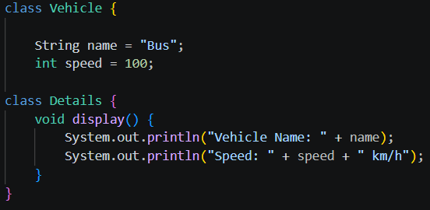
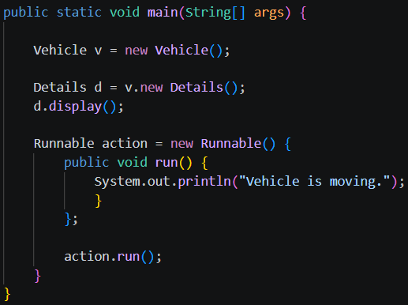
Outcome
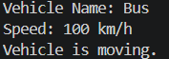
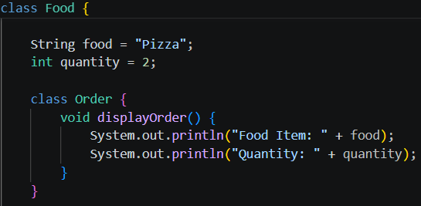
2. Develop a Food Delivery Application where an inner class handles order details and anonymous classes handle delivery status updates.

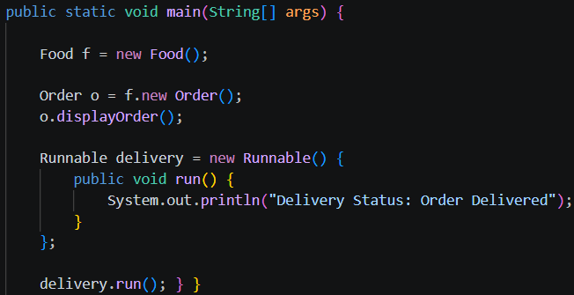
Outcome
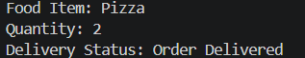
Conclusion:
This program demonstrates the use of an inner class and an anonymous class in Java. The inner class is used to display the food order details, while the anonymous class is used to update the delivery status. These concepts help organize code, reduce unnecessary class creation, and make Java programs simpler and more efficient.

